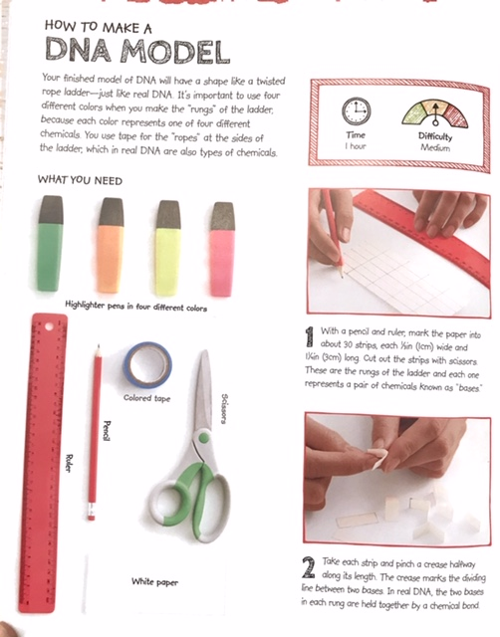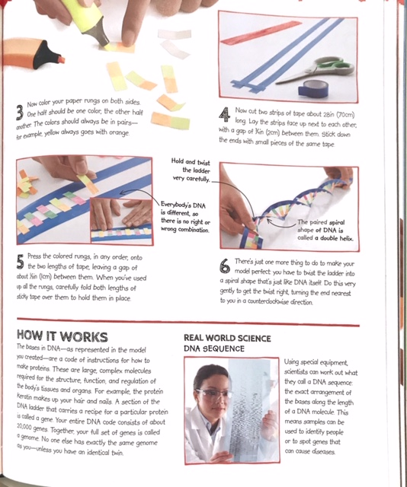
DNA Model Additional Resources
https://kera.pbslearningmedia.org/resource/tdc02.sci.life.repro.lp_dnastructure/modeling-dna-structure/

