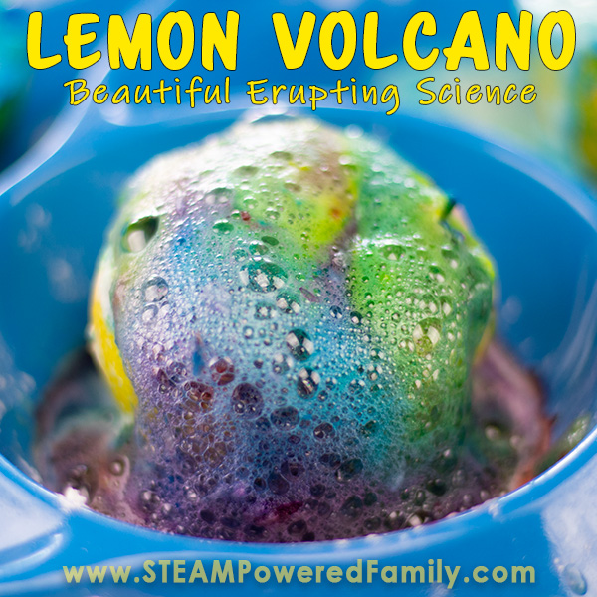

Lemon Volcano Experiment for Kids
Kids will love any experiment that erupts. So, proposing the use of lemon battery cells to create exploding lemons, would excite any kid!
First, exploding lemons is probably creating the wrong impression. This is not Fruit Ninja and no fruits explode. They do however erupt in a spectacular way. These yellow pieces of summer sunshine bubble over into a gorgeous lemon volcano.
Next, I have to say this is one of the most beautiful, amazing smelling, sensory rich science experiments. Just the visual play of the food coloring during the reactions was mesmerizing. Plus, the whole time you are emerged in the wondrous smell of fresh lemons. Now this is some gorgeous science!

Lemon Volcano Supplies
The best part of this science experiment is that is uses items you already have around the house.
Lemons! As many as you want to use.
Knife
Cutting board
Craft sticks
Food coloring
Dish soap
Baking soda
Large dish (to capture the spill over)

How to Make A Volcano Out Of A Lemon?
- Safety first!
We are working with an acid. Use your best judgement on the capabilities of your children. Use gloves, safety goggles, aprons as needed, and always ensure kids do these experiments under responsible adult supervision.
- Roll your lemons. If you know anything about lemons, you know rolling them is important to get the juices flowing before you cut. In this experiment, the juices are critical, so we want our lemon nice and juicy. Simply roll it on the table with some pressure on it from your hand to start those lemon juices flowing.
- Then cut all your lemons in half after rolling them.
- Once they are cut in half, use a craft stick to poke into the flesh of the lemon and release those juices a little more.
- Set your lemons on your large plate. If they won’t stand up, simply cut a flat part onto the bottom.
- Add a few drops of food coloring. We really enjoyed mixing up our colors and creating a rainbow of volcanoes.
- Next add a dribble of dish soap to each lemon.
- Now is when the chemistry and science fun starts! Sprinkle the top of the lemon with a generous layer of baking soda. You will notice a little bit of reaction starts immediately.
- But we want our lemon volcanoes to have epic eruptions!
- So now we need to take our craft sticks and poke our lemons to really push the baking soda into the lemon and mix it with the lemon juice.
Now we have a lemon volcano eruption!

Video of Erupting Lemon Volcano Science Experiment

https://www.steampoweredfamily.com/activities/science-experiments-kids-lemon-volcano/?jwsource=cl

Lemon Science – Why Does A Lemon Volcano Erupt?
So, what makes our lemons explode with such awesomeness? It all comes down to one of our favorite chemistry reactions, the interaction between acids and bases which results in the release of CO2 gas (the bubbles). The dish soap helps capture the gas so we can see it as bubbles during the reaction.
In many of our experiments we use vinegar for our acid, but lemons work as well. Why? Because lemons are full of citric acid. That is what gives them that sour flavor. That acid reacts with baking soda (a basic) and gives us our big reactions.
Here is the chemical reaction taking place in our lemon volcano: H₃C₆H₅O_{7 (aq)} + 3NaHCO_{3 (s)} → 3CO_{2 (g)} + 3H₂O _{(l)} + Na₃C₆H₅O_{7 (aq)}

More Ways to Explore the Chemistry Behind Volcano Experiments
We have done entire experiments focused on exploring the acid-based chemical reaction. Kids love experiments that erupt and bubble. The spectacular results are sure to get all kids thrilled about chemistry.
There are several different science experiments for kids that will explore this chemical reaction. Here are some of our favorites. Simply click on the image for more details on each activity.
What you will discover in this article!
- Lemon Volcano Experiment For Kids
- Lemon Volcano Supplies
- How To Make A Volcano Out Of A Lemon
- Video Of Erupting Lemon Volcano Science Experiment
- Lemon Science – Why Does A Lemon Volcano Erupt?
- More Ways To Explore The Chemistry Behind Volcano Experiments
- More Lemon Science Project Ideas
- More Science Experiments

