TEXAS MODEL UNITED NATIONS
COUNTRY PROFILE

The following is a form designed to guide your research about your country. The questions asked will help to prepare you for the conference. However, they by no means cover every aspect of your country. Therefore, you should answer the questions as completely and clearly as possible, as well as including any information that you find important on separate sheets, attached at the end. Please type your answers and be sure to keep a copy for yourself.

GENERAL INFORMATION
Point out the country's location on the map below:
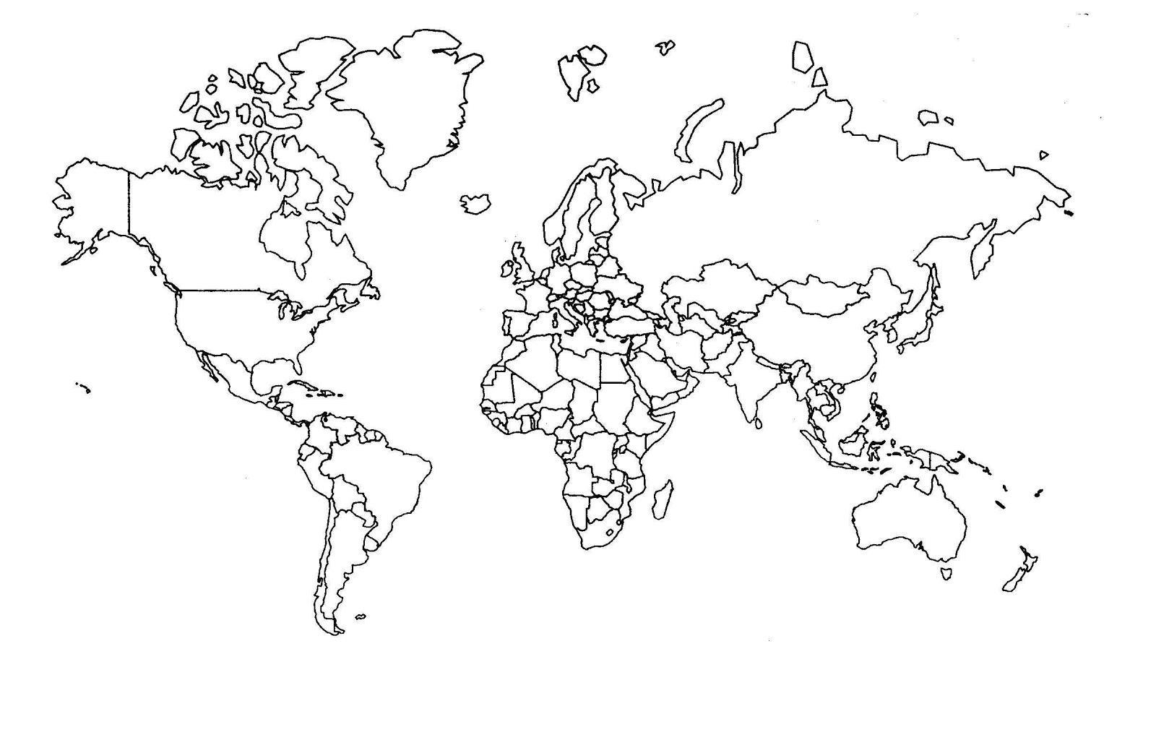
Country: __________________________________
Location (continent):_________________________ Latitude:_________ Longitude: ________ Population:________________________________ Area (in square miles):_____________________
Official Language(s):_________________________________________________________________
Other Language(s) Spoken: _____________________________________________________________
Capital City: _____________________________ U.N. Ambassador:_____________________________

HISTORY
Date country came into existence (or date of most recent constitutional government):____________

Discuss what groups of people make up your country (Include both indigenous people and any waves of immigration, either ancient or modern).

Has your country ever been colonized or gained control over others? What other countries?

Discuss any major wars in the country's history, either foreign or civil. When and why did they happen and what was their outcome?

ECONOMY
Discuss the economic status of your country. Include facts such as its industrialized status, gross national product, per capita income, its economic status in comparison to neighboring countries and any other economic information that seems relevant.

What are the primary industries of the country? (Include chief crops, minerals, livestock and other statistics about the resources and the labor force.)

ECONOMY, continued
What is the country’s situation with world trade? (Include major import/export products, who your trading partners are, whether the country has a trade surplus or deficit and what tariffs you impose or are affected by.)

GOVERNMENT
What is the leadership of the country? Who are the leaders and what are their political affiliations?

Discuss how this government came into power and how stable it is.

What is the country's current military capability?

CULTURE
What is the life-expectancy at birth? Note the birth & death rates and the rate of infant mortality.

What are the main religions of your country and how do they relate to each other?

Discuss the educational system. What is the literacy rate? Is the education secular or sectarian?

What is the typical family life like?

What are some typical pastimes?

CULTURE, continued
How is the population distributed among cities vs. rural areas?

Describe the average diet. What is the traditional style of cooking?

What is the climate like?

Describe the health care system. Include information on availability, quality, and cost.

What are the primary modes of transportation in the country?

UNITED NATIONS INFO
Year country joined the United Nations: ________________

On which UN organs/bodies is the country represented?

NOTES ON YOUR NATION’S DEALINGS WITH CURRENT CONFERENCE TOPICS:

